DBMS & SQL
Complete Interview Preparation Guide — A to Z
Fundamentals · Normalization · SQL · Joins · Transactions · Indexing · NoSQL · Design Patterns
On-Campus Fresher SDE Interviews
Theory + Code + Examples + Interview Questions + Query Practice

SECTION 1: DBMS Fundamentals

1.1 What is DBMS?
Q: What is a DBMS and how does it differ from a file system?
Answer:
DBMS (Database Management System): Software that manages, stores, retrieves, and manipulates structured data. Provides a systematic way to create, maintain, and control access to a database.
Property | File System | DBMS
Data access | Complex programs needed | Simple SQL queries
Data redundancy | High — same data in multiple files | Low — normalised tables
Data inconsistency | Different files can contradict | ACID keeps data consistent
Concurrent access | No built-in control | Transaction management built-in
Security | File-level OS permissions | Fine-grained user/role/table permissions
Crash recovery | Manual / not built-in | Automatic WAL + rollback
Data independence | Tight coupling app+data | Physical/Logical independence

1.2 DBMS vs RDBMS
Q: What is the difference between DBMS and RDBMS?
Answer:
Feature | DBMS | RDBMS
Data storage | Any format (hierarchical, network) | Tables with rows and columns
Relationships | Not enforced | Foreign keys enforce relationships
ACID | Not necessarily supported | Fully supported
SQL | May or may not support | Standard SQL supported
Examples | XML DB, IMS | MySQL, PostgreSQL, Oracle, SQL Server

1.3 Three-Schema Architecture
Q: Explain the three-schema (ANSI/SPARC) architecture.
Answer:
- External Schema (View level): What end users see. Multiple views tailored for different user types. Hides physical complexity.
- Conceptual Schema (Logical level): How data is logically organised — tables, relationships, constraints. Independent of physical storage.
- Internal Schema (Physical level): How data is physically stored — file organisation, indexes, storage blocks.
Data independence: Logical independence = change conceptual schema without affecting views. Physical independence = change storage without affecting conceptual schema.

1.4 Database Keys
Q: Explain all types of keys in a database.
Answer:
Key Type | Definition | Example
Super Key | Any set of attributes that uniquely identifies a row. Superset of candidate key. | {StudentID}, {StudentID, Name}, {Email}
Candidate Key | Minimal super key — no redundant attributes. Can be Primary Key. | StudentID, Email
Primary Key | Chosen candidate key. Cannot be NULL. Only one per table. | StudentID (chosen from candidates)
Foreign Key | Attribute referencing Primary Key of another table. Enforces referential integrity. | OrderTable.CustomerID → CustomerTable.CustomerID
Composite Key | Primary key made of two or more attributes. | (StudentID, CourseID) in Enrollment table
Unique Key | Like Primary Key but allows one NULL. Can have multiple per table. | Email column — unique but nullable
Alternate Key | Candidate keys not chosen as Primary Key. | Email (when StudentID is PK)

1.5 ER Model
Q: What are the components of an ER diagram? Explain cardinality.
Answer:
Entity: A real-world object with independent existence. Represented by a rectangle. Example: Student, Course, Employee.
Attributes: Properties of an entity. Types:
- Simple: Cannot be divided further (Name, Age)
- Composite: Can be divided (FullName = FirstName + LastName)
- Multi-valued: Can have multiple values (Phone numbers — multiple)
- Derived: Computed from another (Age derived from DateOfBirth)
Relationships: Association between entities. Cardinality defines how many instances participate:
Cardinality | Meaning | Example
One-to-One (1:1) | One entity relates to exactly one other | Person ↔ Passport
One-to-Many (1:N) | One entity relates to many | Department → many Employees
Many-to-Many (M:N) | Many relate to many (needs junction table) | Student ↔ Course (via Enrollment)

SECTION 2: Normalization — Highest Priority Topic

2.1 Why Normalization?
Q: What is normalization? Why do we need it?
Answer:
Normalization: Process of organising a database to reduce redundancy and improve data integrity by decomposing tables to eliminate anomalies while preserving dependencies.
Three anomalies it prevents:
- Update Anomaly: If a teacher's name is stored with every student enrollment, updating the name requires changing all rows. Miss one → inconsistency.
- Insert Anomaly: Cannot add a course to the DB until at least one student enrolls in it (if student+course are in the same table with a composite PK).
- Delete Anomaly: Deleting the last student enrolled in a course accidentally deletes the course itself.
Functional Dependency (FD): X → Y means knowing X determines Y uniquely. Example: StudentID → StudentName (knowing ID tells us the name).

2.2 Normalization Journey — Diagram
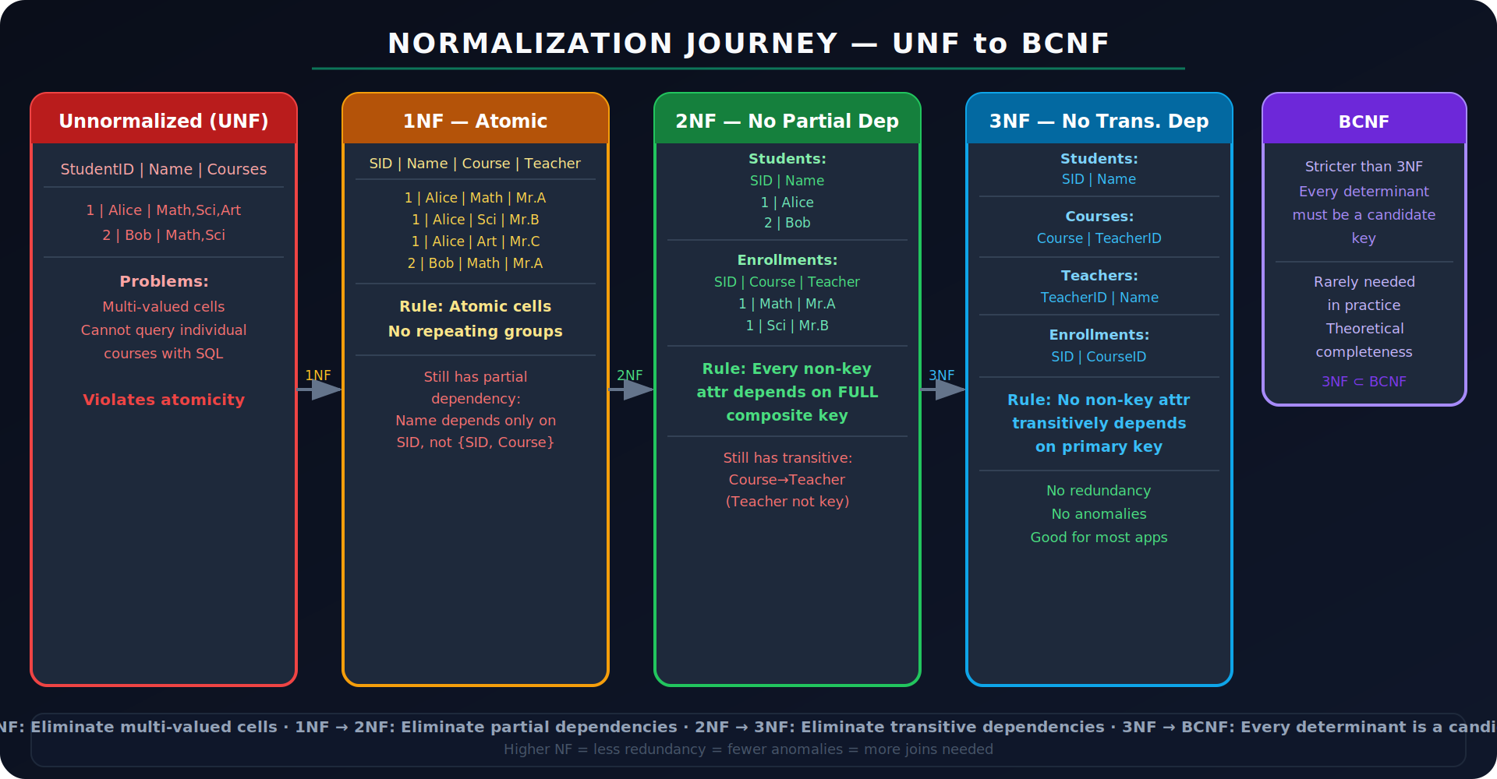
Figure 1: Normalization — UNF → 1NF → 2NF → 3NF → BCNF

2.3 Normal Forms — Detailed Rules
1NF — First Normal Form
Rule: Every column must contain atomic (indivisible) values. No repeating groups or arrays.
Before 1NF — Problem:

-- VIOLATES 1NF: Courses column has multiple values in one cell
StudentID | Name | Courses
1 | Alice | Math, Science, Art
2 | Bob | Math, English

After 1NF — Fixed:

-- 1NF: Each cell atomic, each row unique
StudentID | Name | Course
1 | Alice | Math
1 | Alice | Science
1 | Alice | Art
2 | Bob | Math
2 | Bob | English
-- PK: (StudentID, Course)

2NF — Second Normal Form
Rule: Must be in 1NF AND every non-key attribute must be FULLY functionally dependent on the ENTIRE primary key (no partial dependencies). Applies when PK is composite.
Before 2NF — Problem:

-- Table with composite PK (StudentID, CourseID)
StudentID | CourseID | StudentName | CourseName | Grade
-- FDs:
-- StudentID -> StudentName (partial: StudentName depends on part of PK)
-- CourseID -> CourseName (partial: CourseName depends on part of PK)
-- (StudentID, CourseID) -> Grade (full dependency - OK)

After 2NF — Remove partial dependencies:

-- Students table (StudentID is sole PK)
StudentID | StudentName

-- Courses table (CourseID is sole PK)
CourseID | CourseName

-- Enrollment table (composite PK)
StudentID | CourseID | Grade -- Grade fully depends on (StudentID, CourseID)

3NF — Third Normal Form
Rule: Must be in 2NF AND no non-key attribute should transitively depend on the primary key through another non-key attribute.
Transitive dependency: A → B → C where A is PK, B is non-key. C transitively depends on A through B.
Before 3NF — Problem:

-- Employee table
EmpID | EmpName | DeptID | DeptName | DeptLocation
-- FDs:
-- EmpID -> DeptID (direct - OK)
-- DeptID -> DeptName (transitive! DeptName depends on non-key DeptID)
-- DeptID -> DeptLocation (transitive!)
-- Problem: If dept name changes, must update ALL employee rows -> Update anomaly

After 3NF — Remove transitive dependencies:

-- Employees
EmpID | EmpName | DeptID -- DeptID is FK

-- Departments
DeptID | DeptName | DeptLocation -- DeptName/Location depend ONLY on DeptID (PK)

-- Now DeptName stored once. Change it in one place. No anomaly.

BCNF — Boyce-Codd Normal Form
Rule: Stricter than 3NF. For every functional dependency X → Y, X must be a candidate key. In 3NF, a non-candidate-key can determine another attribute if Y is part of a key. BCNF eliminates this.
Classic BCNF violation example:

-- Student-Teacher-Course (each teacher teaches only one subject)
Student | Teacher | Course
-- FDs: (Student, Course) -> Teacher (PK)
-- Teacher -> Course (Teacher determines Course)
-- Teacher is NOT a candidate key, but determines Course -> BCNF violation
-- 3NF compliant (Course is part of key), but BCNF violated

-- Fix: Decompose into
TeacherCourse: Teacher | Course (Teacher -> Course, Teacher is CK)
StudentTeacher: Student | Teacher (Student, Teacher -> unique combo)

Interview Tip: BCNF may not always be achievable without losing some functional dependencies. 3NF is a safe practical target.

2.4 Tricky Normalization Examples
Tricky Example 1 — 1NF to 2NF

-- GIVEN: OrderDetails (OrderID, ProductID, ProductName, Qty, UnitPrice)
-- PK: (OrderID, ProductID)
-- FDs: ProductID -> ProductName, ProductID -> UnitPrice
-- (OrderID, ProductID) -> Qty

-- In 1NF? YES (atomic values)
-- In 2NF? NO — ProductName and UnitPrice depend on only ProductID (partial dep)

-- 2NF Decomposition:
Products: (ProductID [PK], ProductName, UnitPrice)
OrderItems: (OrderID, ProductID [FK], Qty) -- PK: (OrderID, ProductID)

Tricky Example 2 — 2NF to 3NF

-- GIVEN: Employee(EmpID, Name, Zip, City, State)
-- PK: EmpID
-- FDs: EmpID -> Zip, Zip -> City, Zip -> State

-- In 2NF? YES (no composite PK, no partial deps possible)
-- In 3NF? NO — City and State transitively depend on EmpID through Zip
-- EmpID -> Zip -> City (transitive!)

-- 3NF Decomposition:
Employees: (EmpID [PK], Name, Zip [FK])
ZipCodes: (Zip [PK], City, State)

Tricky Example 3 — Denormalization tradeoff

-- SCENARIO: E-commerce Order Summary page
-- Must show: OrderID, CustomerName, Total, ItemCount
-- Normalized: requires JOIN across Orders, Customers, OrderItems tables
-- Very high read volume (millions/sec) makes joins expensive

-- DENORMALIZE: Add CustomerName, Total, ItemCount as columns in Orders
Orders: (OrderID, CustomerID, CustomerName, Total, ItemCount, ...)
--
-- Tradeoff: Redundancy + update anomaly risk vs. faster reads
-- Real-world: reporting tables, analytics, caching layers use denormalization

SECTION 3: SQL Fundamentals

3.1 SQL Categories
Category | Commands | Notes
DDL — Data Definition Language | CREATE, ALTER, DROP, TRUNCATE, RENAME | Defines structure. AUTO-COMMIT. Cannot rollback.
DML — Data Manipulation Language | INSERT, UPDATE, DELETE, SELECT | Manipulates data. Can be rolled back.
DCL — Data Control Language | GRANT, REVOKE | Access control for users/roles.
TCL — Transaction Control Language | BEGIN, COMMIT, ROLLBACK, SAVEPOINT | Manages transactions.

3.2 Basic Queries

-- SELECT with all common clauses
SELECT DISTINCT department, COUNT(*) AS emp_count
FROM employees
WHERE salary > 50000
AND department IS NOT NULL
ORDER BY emp_count DESC
LIMIT 5;

-- CRUD Operations
INSERT INTO employees (name, department, salary)
VALUES ('Alice', 'Engineering', 75000);

UPDATE employees
SET salary = salary * 1.10 -- 10% raise
WHERE department = 'Engineering';

DELETE FROM employees
WHERE last_active < '2020-01-01';

3.3 Constraints

CREATE TABLE employees (
emp_id INT PRIMARY KEY, -- NOT NULL + UNIQUE
email VARCHAR(100) UNIQUE, -- must be unique, nullable
name VARCHAR(50) NOT NULL, -- cannot be null
salary DECIMAL(10,2) DEFAULT 30000 CHECK (salary >= 0),
dept_id INT REFERENCES departments(dept_id) -- FK
ON DELETE SET NULL ON UPDATE CASCADE
);

-- ON DELETE options:
-- CASCADE : delete child rows when parent deleted
-- SET NULL : set FK to NULL when parent deleted
-- RESTRICT : prevent deletion of parent if children exist
-- NO ACTION : similar to RESTRICT (default)

SECTION 4: SQL Joins — Most Important SQL Topic

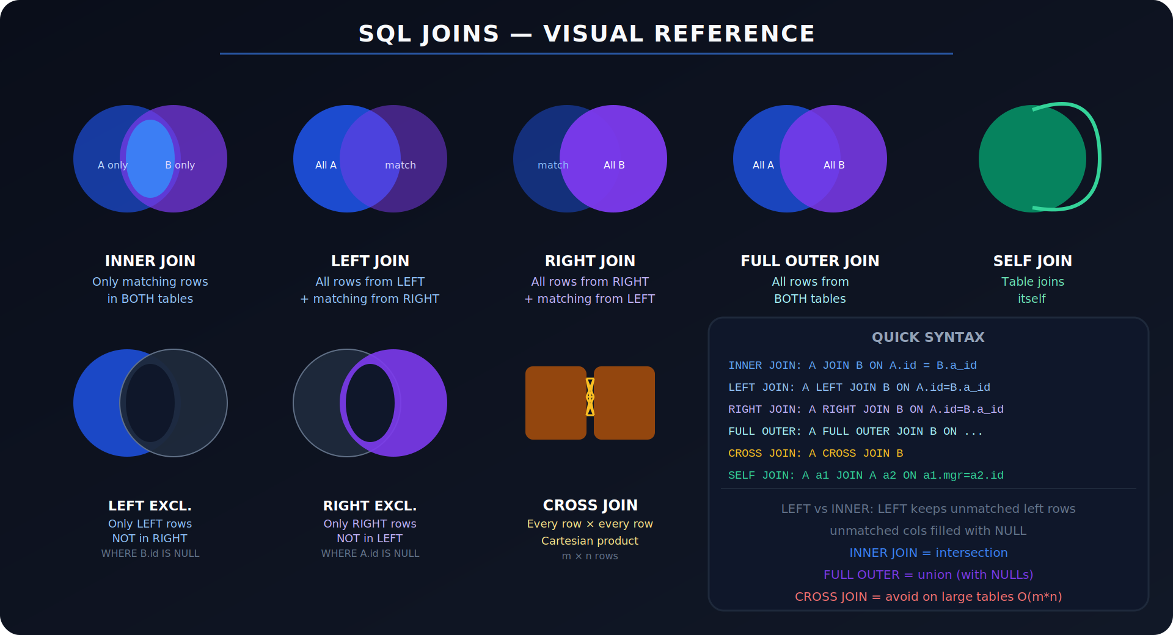
Figure 2: SQL Joins Visual Reference — All 7 Join Types

4.1 INNER JOIN
Returns only rows where there is a match in BOTH tables.

-- Tables: Employees(emp_id, name, dept_id), Departments(dept_id, dept_name)
SELECT e.name, d.dept_name
FROM employees e
INNER JOIN departments d ON e.dept_id = d.dept_id;
-- Only employees WITH a department are returned
-- Employees with NULL dept_id are EXCLUDED

4.2 LEFT JOIN
Returns all rows from LEFT table. Matched rows from RIGHT table. Unmatched right cols → NULL.

-- Find all employees including those without departments
SELECT e.name, d.dept_name
FROM employees e
LEFT JOIN departments d ON e.dept_id = d.dept_id;
-- Employees with no dept: dept_name = NULL

-- LEFT EXCLUSIVE JOIN: only rows NOT in right table
SELECT e.name
FROM employees e
LEFT JOIN departments d ON e.dept_id = d.dept_id
WHERE d.dept_id IS NULL; -- employees with NO matching department

4.3 RIGHT JOIN & FULL OUTER JOIN

-- RIGHT JOIN: all from right + matching from left
SELECT e.name, d.dept_name
FROM employees e
RIGHT JOIN departments d ON e.dept_id = d.dept_id;
-- Includes departments with no employees (e.name = NULL)

-- FULL OUTER JOIN: all from both, NULLs where no match
SELECT e.name, d.dept_name
FROM employees e
FULL OUTER JOIN departments d ON e.dept_id = d.dept_id;
-- MySQL: emulate with UNION of LEFT + RIGHT
SELECT e.name, d.dept_name FROM employees e LEFT JOIN departments d ON e.dept_id = d.dept_id
UNION
SELECT e.name, d.dept_name FROM employees e RIGHT JOIN departments d ON e.dept_id = d.dept_id;

4.4 SELF JOIN
A table joining itself. Classic use: employee-manager hierarchy.

-- Find each employee and their manager's name
SELECT e.name AS employee, m.name AS manager
FROM employees e
LEFT JOIN employees m ON e.manager_id = m.emp_id;
-- LEFT JOIN so top-level managers (no manager) still appear with NULL manager

-- Employees without a manager (CEO / top-level)
SELECT name FROM employees WHERE manager_id IS NULL;

4.5 JOIN Practice Questions
Customers without any orders

SELECT c.customer_id, c.name
FROM customers c
LEFT JOIN orders o ON c.customer_id = o.customer_id
WHERE o.order_id IS NULL; -- no matching order

Highest salary per department

SELECT dept_id, MAX(salary) AS max_salary
FROM employees
GROUP BY dept_id;

-- With employee name using JOIN
SELECT e.name, e.dept_id, e.salary
FROM employees e
JOIN (SELECT dept_id, MAX(salary) ms FROM employees GROUP BY dept_id) m
ON e.dept_id = m.dept_id AND e.salary = m.ms;

Second highest salary

-- Method 1: Subquery (works everywhere)
SELECT MAX(salary) FROM employees
WHERE salary < (SELECT MAX(salary) FROM employees);

-- Method 2: OFFSET
SELECT DISTINCT salary FROM employees
ORDER BY salary DESC LIMIT 1 OFFSET 1;

-- Method 3: Dense rank (best for Nth highest)
SELECT salary FROM (
SELECT salary, DENSE_RANK() OVER (ORDER BY salary DESC) AS rnk
FROM employees
) ranked WHERE rnk = 2;

Find duplicate records

-- Find emails that appear more than once
SELECT email, COUNT(*) AS cnt
FROM employees
GROUP BY email
HAVING COUNT(*) > 1;

-- Get all duplicate rows with details
SELECT * FROM employees
WHERE email IN (
SELECT email FROM employees GROUP BY email HAVING COUNT(*) > 1
);

SECTION 5: Aggregate Functions & Grouping

5.1 Aggregate Functions

SELECT
COUNT(*) AS total_rows, -- all rows including NULLs
COUNT(salary) AS non_null_salaries, -- excludes NULLs
COUNT(DISTINCT dept_id) AS dept_count, -- distinct values
SUM(salary) AS total_payroll,
AVG(salary) AS avg_salary,
MAX(salary) AS highest,
MIN(salary) AS lowest
FROM employees;

5.2 GROUP BY and HAVING
Q: What is the difference between WHERE and HAVING?
Answer:
WHERE: Filters rows BEFORE aggregation. Cannot use aggregate functions.
HAVING: Filters groups AFTER aggregation. Used with GROUP BY. Can use aggregate functions.

-- Count employees per department where dept has > 5 employees
SELECT dept_id, COUNT(*) AS emp_count, AVG(salary) AS avg_sal
FROM employees
WHERE salary > 30000 -- filter rows BEFORE grouping
GROUP BY dept_id
HAVING COUNT(*) > 5 -- filter groups AFTER aggregation
ORDER BY avg_sal DESC;

-- Order of SQL clause execution:
-- FROM -> WHERE -> GROUP BY -> HAVING -> SELECT -> DISTINCT -> ORDER BY -> LIMIT

5.3 Query Execution Order
Interview Key: SQL clauses execute in this order: FROM → JOIN → WHERE → GROUP BY → HAVING → SELECT → DISTINCT → ORDER BY → LIMIT. This explains why you CANNOT use a SELECT alias in WHERE — WHERE executes before SELECT.

SECTION 6: Transactions, ACID & Concurrency

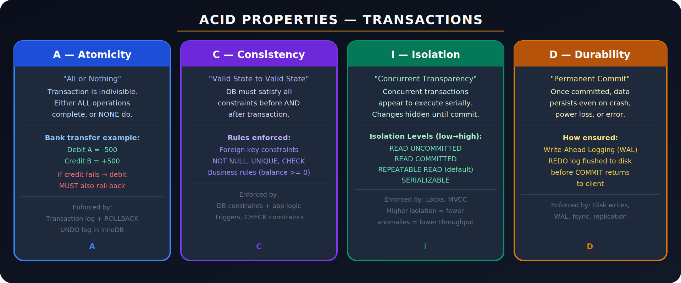
Figure 3: ACID Properties — Atomicity, Consistency, Isolation, Durability

6.1 Transactions — TCL Commands

-- Transaction example: bank transfer
BEGIN; -- or START TRANSACTION

UPDATE accounts SET balance = balance - 500 WHERE acc_id = 1;
UPDATE accounts SET balance = balance + 500 WHERE acc_id = 2;

-- Check if valid
-- If error occurs:
ROLLBACK; -- undo ALL changes since BEGIN

-- If all good:
COMMIT; -- permanently save all changes

-- SAVEPOINT: partial rollback
BEGIN;
INSERT INTO logs ...; SAVEPOINT after_log;
UPDATE products ...;
ROLLBACK TO SAVEPOINT after_log; -- undo UPDATE but keep INSERT
COMMIT;

6.2 ACID — Detailed Explanation
Q: Explain ACID properties with a real example.
Answer:
Example: Transfer Rs 500 from Account A to Account B
- Atomicity: Both debit (A-500) and credit (B+500) must succeed, or both must fail. If credit fails after debit → rollback the debit. No partial execution.
- Consistency: Before: A=1000, B=500, Total=1500. After: A=500, B=1000, Total=1500. Total money never changes — constraints preserved.
- Isolation: If another transaction reads A's balance mid-transfer, it sees either old value (1000) or new value (500), never an intermediate state. Controlled by isolation levels.
- Durability: Once COMMIT returns success, the transfer is permanent. Even if server crashes immediately after, WAL ensures data is recoverable.

6.3 Concurrency Problems & Isolation Levels
Q: What are dirty reads, phantom reads, and lost updates?
Answer:
Problem | Description | Solution
Dirty Read | T1 reads data modified by T2 that hasn't committed yet. T2 rolls back → T1 has read invalid data. | Fixed by: READ COMMITTED+
Non-Repeatable Read | T1 reads a row, T2 updates+commits it, T1 reads again → different value within same transaction. | Fixed by: REPEATABLE READ+
Phantom Read | T1 runs a range query, T2 inserts a new row in that range, T1 reruns query → new row appears. | Fixed by: SERIALIZABLE
Lost Update | T1 and T2 both read a value, both modify it — T2's write overwrites T1's write. | Fixed by: pessimistic/optimistic locking

Isolation Level | Behaviour | Use Case
READ UNCOMMITTED | Fastest, least safe. Allows dirty reads, phantom reads. | Almost never used in practice
READ COMMITTED | Most DBs default. No dirty reads. Non-repeatable reads possible. | PostgreSQL default
REPEATABLE READ | No dirty/non-repeatable reads. Phantom reads possible. | MySQL InnoDB default
SERIALIZABLE | Strictest. Transactions run as if serial. Slowest. | Financial/banking critical sections

SECTION 7: Indexing & Query Optimisation

7.1 What is an Index?
Q: What is a database index and why does it improve SELECT performance?
Answer:
Index: A separate data structure (usually a B-tree or hash table) that the DB engine maintains alongside the table. It stores key-value pairs mapping column values to their row locations, allowing the engine to find rows without scanning the entire table.
Analogy: Index of a book. Instead of reading every page to find 'normalization', you look it up in the back index → jump directly to page 47. Full table scan = reading every page.
Without index: O(n) full table scan — reads every row. 1M rows = 1M comparisons.
With index: O(log n) B-tree lookup — binary search. 1M rows = only ~20 comparisons.

-- Create index
CREATE INDEX idx_emp_salary ON employees(salary);
CREATE UNIQUE INDEX idx_emp_email ON employees(email);
CREATE INDEX idx_composite ON employees(dept_id, salary); -- composite

-- Query now uses index (check with EXPLAIN)
SELECT * FROM employees WHERE salary > 50000;

EXPLAIN SELECT * FROM employees WHERE salary > 50000;
-- Look for: 'Using index' vs 'Using filesort' vs 'ALL' (full scan)

7.2 Clustered vs Non-Clustered Index
Q: What is the difference between clustered and non-clustered indexes?
Answer:
Type | Description | Example
Clustered | Data rows physically stored in index key order. Only 1 per table. PK usually clustered. | InnoDB PK, SQL Server clustered
Non-Clustered | Separate structure with pointers to actual rows. Multiple allowed per table. | Most secondary indexes (email, name)
Key insight: Clustered index lookup is faster (data is the index leaf). Non-clustered requires an extra 'bookmark lookup' — find row pointer in index, then fetch actual row from heap.

7.3 B-Tree vs Hash Index
Type | Properties | Use Case
B-Tree Index | Balanced tree. Supports range queries (>, <, BETWEEN, LIKE 'abc%'). | General purpose — default for most columns
Hash Index | Hash table. O(1) exact match. NO range queries. | Only for equality: WHERE email = 'x@y.com'

7.4 When NOT to Use Index?
Q: Why does indexing speed up SELECT but slow down INSERT/UPDATE/DELETE?
Answer:
INSERT/UPDATE/DELETE overhead: Every write must update ALL indexes on the table. Insert a row → update B-tree for every index on that table. More indexes = more B-tree maintenance = slower writes.
When NOT to index:
- Columns with very low cardinality (e.g., a gender column with only 2 values — index won't help, full scan often faster)
- Small tables — full scan is fast enough, index overhead not worth it
- Columns rarely used in WHERE, JOIN, or ORDER BY
- Columns with frequent updates — constant B-tree rebalancing
- Avoid too many indexes on write-heavy OLTP tables

7.5 Query Optimisation Techniques
Q: How would you optimise a slow SQL query?
Answer:
- Use EXPLAIN / EXPLAIN ANALYZE: Check if query is doing full table scan (type=ALL). Look for 'Using filesort', 'Using temporary'.
- Add missing indexes: Index on columns in WHERE, JOIN ON, and ORDER BY clauses.
- Avoid SELECT *: Fetch only needed columns. Reduces I/O and memory.
- Avoid functions on indexed columns in WHERE: WHERE YEAR(created_at) = 2023 prevents index use. Use WHERE created_at BETWEEN '2023-01-01' AND '2023-12-31' instead.
- Rewrite correlated subqueries as JOINs: Correlated subqueries run once per row. JOIN is usually faster.
- Pagination with cursor instead of OFFSET: LIMIT 10 OFFSET 100000 scans and discards 100k rows. Use WHERE id > last_seen_id LIMIT 10 instead.

-- SLOW: function on indexed column
SELECT * FROM orders WHERE YEAR(order_date) = 2023; -- full scan!

-- FAST: range condition allows index use
SELECT * FROM orders WHERE order_date >= '2023-01-01' AND order_date < '2024-01-01';

-- SLOW: correlated subquery (runs N times)
SELECT * FROM employees e WHERE salary > (SELECT AVG(salary) FROM employees WHERE dept_id = e.dept_id);

-- FASTER: derived table / subquery in FROM
SELECT e.* FROM employees e
JOIN (SELECT dept_id, AVG(salary) avg_sal FROM employees GROUP BY dept_id) d
ON e.dept_id = d.dept_id AND e.salary > d.avg_sal;

SECTION 8: Views, Stored Procedures & Triggers

8.1 Views
Q: What is a view? How is it different from a table?
Answer:
View: A virtual table defined by a SQL query. Does not store data itself — it's a stored query. Every time you query a view, the underlying query runs.

-- Create view
CREATE VIEW high_earners AS
SELECT name, salary, department
FROM employees
WHERE salary > 70000;

-- Use like a table
SELECT * FROM high_earners ORDER BY salary DESC;

-- Updatable view (simple views can be updated)
UPDATE high_earners SET salary = 80000 WHERE name = 'Alice';

-- Drop view
DROP VIEW high_earners;

-- Benefits: security (hide sensitive columns), simplification, abstraction
-- Limitation: performance (not cached usually), complex views not updatable

8.2 Stored Procedures

-- Stored procedure: reusable SQL block with logic
DELIMITER $$
CREATE PROCEDURE GetEmpByDept(IN dept_name VARCHAR(50))
BEGIN
SELECT e.name, e.salary
FROM employees e
JOIN departments d ON e.dept_id = d.dept_id
WHERE d.dept_name = dept_name;
END $$
DELIMITER ;

-- Call it
CALL GetEmpByDept('Engineering');

-- Benefits: reduced network traffic, reusability, security, precompiled
-- Drawbacks: hard to version control, DB-specific syntax, logic in DB

8.3 Triggers

-- Trigger: auto-executed on INSERT/UPDATE/DELETE
CREATE TRIGGER log_salary_change
AFTER UPDATE ON employees
FOR EACH ROW
BEGIN
IF OLD.salary != NEW.salary THEN
INSERT INTO salary_audit(emp_id, old_sal, new_sal, changed_at)
VALUES (NEW.emp_id, OLD.salary, NEW.salary, NOW());
END IF;
END;

-- Trigger timing: BEFORE or AFTER
-- Trigger events: INSERT, UPDATE, DELETE
-- Use cases: audit logging, auto-update timestamps, enforcing complex rules
-- Caution: hidden logic, hard to debug, performance impact

SECTION 9: NoSQL — Theory, Types & When to Use

9.1 What is NoSQL?
Q: What is NoSQL? When would you choose NoSQL over SQL?
Answer:
NoSQL (Not Only SQL): Non-relational databases designed for specific data models — document, key-value, wide-column, or graph. Built for horizontal scaling, high throughput, and flexible schema.
Property | SQL (RDBMS) | NoSQL
Schema | Fixed schema, ALTER TABLE needed | Dynamic / schemaless
Scale | Vertical (bigger server) | Horizontal (more servers / sharding)
ACID | Full ACID support | Often BASE (Eventually Consistent)
Query Language | SQL — rich queries, joins | DB-specific APIs, limited joins
Relationships | Enforced via FK, JOINs | Denormalized, embedded docs
Best for | Structured data, complex queries | High-scale, flexible data, fast reads

9.2 NoSQL Types with Examples
Type | Examples | Best Use Case
Key-Value | Redis, DynamoDB, Riak | key → value. Fastest. Simple lookups. Session data, caching, leaderboards.
Document | MongoDB, CouchDB, Firestore | JSON/BSON documents. Flexible schema. Blogs, catalogs, user profiles.
Wide-Column | Cassandra, HBase, BigTable | Rows with dynamic columns. Time-series, IoT, write-heavy workloads.
Graph | Neo4j, Amazon Neptune | Nodes + edges. Social networks, fraud detection, recommendations.

9.3 CAP Theorem
Q: What is the CAP theorem?
Answer:
CAP: A distributed system can guarantee at most 2 of 3 properties simultaneously:
- Consistency (C): Every read receives the most recent write. All nodes see same data.
- Availability (A): Every request receives a response (not necessarily latest data).
- Partition Tolerance (P): System continues operating despite network partitions (lost messages).
Type | Behaviour | Examples
CP (Consistency + Partition Tolerance) | Available only when network is healthy. Unavailable during partition. | HBase, Zookeeper, MongoDB (default)
AP (Availability + Partition Tolerance) | Returns possibly stale data during partition. Eventually consistent. | Cassandra, CouchDB, DynamoDB
CA (Consistency + Availability) | Not partition tolerant — not feasible for distributed systems. | Traditional RDBMS (single node)

9.4 Case Studies — SQL vs NoSQL
Use NoSQL (MongoDB) when:
- Content Management System — each blog post has different fields (tags, featured image, comments). Flexible schema ideal.
- Real-time analytics dashboard — high write throughput (millions of events/sec). Cassandra wide-column handles time-series better.
- Social network — friend-of-friend queries. Graph DB (Neo4j) traverses relationships orders of magnitude faster than recursive SQL joins.
- Session store / caching layer — Redis key-value: O(1) GET/SET, TTL support, in-memory speed.
Use SQL (PostgreSQL) when:
- Banking / financial systems — ACID compliance mandatory. Complex transactions. No eventual consistency allowed.
- E-commerce with complex queries — JOIN products, inventory, orders, customers with GROUP BY + window functions.
- Reporting and BI — complex aggregations, joins across many tables are SQL's strength.
- Data must conform to strict schema — employee HR system with defined relationships and constraints.

SECTION 10: SQL Query Practice — Easy to Advanced

EASY
Count employees per department

SELECT d.dept_name, COUNT(e.emp_id) AS emp_count
FROM departments d
LEFT JOIN employees e ON d.dept_id = e.dept_id
GROUP BY d.dept_name
ORDER BY emp_count DESC;

Sort employees by salary (top 5)

SELECT name, salary FROM employees ORDER BY salary DESC LIMIT 5;

Find employees with salary above average

SELECT name, salary FROM employees
WHERE salary > (SELECT AVG(salary) FROM employees);

MEDIUM
Nth highest salary (generalised)

-- Replace 3 with any N
SELECT DISTINCT salary FROM employees
ORDER BY salary DESC
LIMIT 1 OFFSET 2; -- 0-indexed: OFFSET N-1 for Nth highest

-- Using DENSE_RANK for more control
SELECT salary FROM (
SELECT salary, DENSE_RANK() OVER (ORDER BY salary DESC) AS rnk
FROM employees
) t WHERE rnk = 3;

Employees earning more than their manager

SELECT e.name AS employee, e.salary, m.name AS manager, m.salary AS mgr_salary
FROM employees e
JOIN employees m ON e.manager_id = m.emp_id
WHERE e.salary > m.salary;

Top 3 salaries per department

SELECT name, dept_id, salary FROM (
SELECT name, dept_id, salary,
DENSE_RANK() OVER (PARTITION BY dept_id ORDER BY salary DESC) AS rnk
FROM employees
) ranked
WHERE rnk <= 3;

ADVANCED
Running total (cumulative sum)

SELECT
order_date,
amount,
SUM(amount) OVER (ORDER BY order_date ROWS UNBOUNDED PRECEDING) AS running_total
FROM orders
ORDER BY order_date;

Consecutive records (e.g., 3+ consecutive days with orders)

-- Find dates where orders exist on 3+ consecutive days
WITH daily AS (
SELECT DISTINCT DATE(order_date) AS ord_day FROM orders
),
gaps AS (
SELECT ord_day,
ord_day - INTERVAL ROW_NUMBER() OVER (ORDER BY ord_day) DAY AS grp
FROM daily
)
SELECT MIN(ord_day), MAX(ord_day), COUNT(*) AS consecutive_days
FROM gaps
GROUP BY grp
HAVING COUNT(*) >= 3;

Ranking queries — RANK vs DENSE_RANK vs ROW_NUMBER

SELECT name, salary,
ROW_NUMBER() OVER (ORDER BY salary DESC) AS row_num,
RANK() OVER (ORDER BY salary DESC) AS rnk,
DENSE_RANK() OVER (ORDER BY salary DESC) AS dense_rnk
FROM employees;

-- Salary: 90 90 80 70
-- ROW_NUMBER: 1 2 3 4 (unique, arbitrary for ties)
-- RANK: 1 1 3 4 (gap after ties)
-- DENSE_RANK: 1 1 2 3 (no gap after ties)

Delete duplicate rows keeping the one with lowest ID

-- Keep the first (lowest id) of each duplicate email
DELETE FROM employees
WHERE emp_id NOT IN (
SELECT MIN(emp_id)
FROM employees
GROUP BY email
);
-- Note: MySQL requires subquery workaround for DELETE from same table

SECTION 11: Frequently Asked Interview Questions

11.1 DELETE vs TRUNCATE vs DROP
Q: What is the difference between DELETE, TRUNCATE, and DROP?
Answer:
Command | Category | Rollback? | Behaviour
DELETE | DML | Yes — can ROLLBACK | Deletes specific rows (with WHERE) or all rows. Triggers fire. Slow (row-by-row).
TRUNCATE | DDL | No — auto-commit | Deletes ALL rows. Faster (deallocates pages). No triggers. Resets identity. Cannot use WHERE.
DROP | DDL | No — auto-commit | Removes entire table structure + data. Cannot select from it afterwards.

11.2 HAVING vs WHERE
Q: When do you use HAVING vs WHERE?
Answer:
WHERE: Filters individual rows BEFORE grouping. Cannot contain aggregate functions.
HAVING: Filters groups AFTER GROUP BY. Can (and usually does) contain aggregate functions.

-- Wrong: aggregate in WHERE
-- SELECT dept_id FROM employees WHERE COUNT(*) > 5; -- ERROR

-- Correct: filter rows with WHERE, filter groups with HAVING
SELECT dept_id, COUNT(*) AS cnt
FROM employees
WHERE hire_date > '2020-01-01' -- filter rows before grouping
GROUP BY dept_id
HAVING COUNT(*) > 5; -- filter groups after aggregation

11.3 Primary Key vs Unique Key
Property | Primary Key | Unique Key
NULL allowed | No | Yes (one NULL typically)
Count per table | Exactly 1 | Multiple allowed
Clustered index | Yes (by default in InnoDB) | No
Purpose | Uniquely identify each row | Enforce uniqueness on non-PK columns

11.4 INNER JOIN vs LEFT JOIN — When to use which?
Q: Why would you use LEFT JOIN instead of INNER JOIN?
Answer:
Use INNER JOIN when: You only want rows that have a match in BOTH tables. Rows without a match are irrelevant.
Use LEFT JOIN when: You want ALL rows from the left table, even if there's no matching row in the right table. Common patterns:
- Find customers who have NOT placed any orders (LEFT JOIN + WHERE orders.id IS NULL)
- List all employees including those not assigned to any department
- Show all products including those never ordered

11.5 Why Does Normalization Help?
Q: Explain in your own words why normalization is important.
Answer:
Without normalization, data is stored redundantly across many rows. If a teacher changes their name, you'd need to update every enrollment row — miss one, and your database now has inconsistent data. Normalization separates this: the teacher's name lives in one row in a Teachers table. Update it once, and every enrollment that references that teacher ID automatically sees the new name. Normalization also prevents insert anomalies (can't add a course without enrolling someone) and delete anomalies (dropping the last student accidentally deletes a course).

11.6 Why Does Indexing Speed Up SELECT?
Q: Explain why indexing improves SELECT performance.
Answer:
Without an index, the database engine does a full table scan — reads every single row to find the matching ones. With a million rows, that's a million comparisons for every query. An index creates a B-tree data structure sorted by the indexed column. The engine can do a binary search — halving the search space each step — finding the right rows in about log2(1,000,000) = ~20 comparisons instead of a million. For range queries, it finds the start point in the tree and reads sequentially. The cost: indexes occupy disk space and must be updated on every write, so you don't index every column.

11.7 What Happens During COMMIT/ROLLBACK?
Q: Explain what happens internally during COMMIT and ROLLBACK.
Answer:
COMMIT flow: (1) All transaction changes are in-memory (buffer pool). (2) COMMIT writes the REDO log to disk (WAL — Write-Ahead Logging). (3) DB acknowledges success to the client. (4) Background process later flushes dirty data pages to disk. Even if crash occurs after step 2, REDO log allows recovery.
ROLLBACK flow: (1) DB reads the UNDO log — records of what values were before the transaction. (2) Applies inverse operations: for each INSERT, performs DELETE; for each UPDATE, restores old value. (3) Releases all locks held by the transaction.

SECTION 12: Quick Reference Cheat Sheet

12.1 Key Definitions — One Line Each
Term | One-Line Definition
Normalization | Decompose tables to eliminate redundancy and anomalies
Functional Dependency | X → Y: X uniquely determines Y
1NF | Atomic cells, no repeating groups
2NF | 1NF + no partial dependencies on composite PK
3NF | 2NF + no transitive dependencies
BCNF | 3NF + every determinant is a candidate key
ACID | Atomicity, Consistency, Isolation, Durability — transaction guarantees
Dirty Read | Reading uncommitted data from another transaction
Phantom Read | A range query returns different rows on re-execution within same transaction
B-Tree Index | Balanced tree index — supports range queries and equality
Clustered Index | Data rows stored in index order. One per table. Usually PK.
Non-Clustered Index | Separate structure with pointers to rows. Multiple per table.
View | Virtual table — stored query, no data storage
Stored Procedure | Precompiled SQL + logic block stored in the DB
Trigger | Auto-executed SQL on INSERT/UPDATE/DELETE event
CAP Theorem | Distributed DB can only guarantee 2 of: Consistency, Availability, Partition Tolerance

12.2 Rapid-Fire SQL One-Liners
Question | Answer
Delete vs Truncate | DELETE: DML, rollbackable, can use WHERE. TRUNCATE: DDL, auto-commit, drops all rows faster.
WHERE vs HAVING | WHERE: before GROUP BY (rows). HAVING: after GROUP BY (groups/aggregates).
INNER vs LEFT JOIN | INNER: only matching rows. LEFT: all left rows, NULLs for unmatched right.
RANK vs DENSE_RANK | RANK: gaps after ties (1,1,3). DENSE_RANK: no gaps (1,1,2).
Second highest salary | SELECT MAX(salary) WHERE salary < (SELECT MAX(salary) FROM table)
Find duplicates | GROUP BY email HAVING COUNT(*) > 1
Index cost | Speeds SELECT via B-tree. Slows INSERT/UPDATE/DELETE (must update index).
Why COUNT(*) vs COUNT(col) | COUNT(*) counts all rows. COUNT(col) skips NULLs.
SQL execution order | FROM → JOIN → WHERE → GROUP BY → HAVING → SELECT → ORDER BY → LIMIT
NoSQL use case | High-scale, flexible schema, horizontal sharding, low-latency key lookups

All the best! Crack that DB interview! 🚀
DBMS & SQL — Complete Interview Preparation Guide

